Name Date
Progress test 3
Listening
Part 1
There are five questions in this part.
For each question there are three pictures and a short recording.
For each question tick the best answer, A, B or C.

- What will the girl take to the class party?
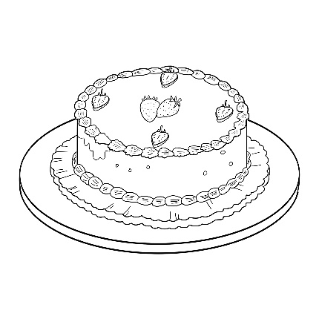
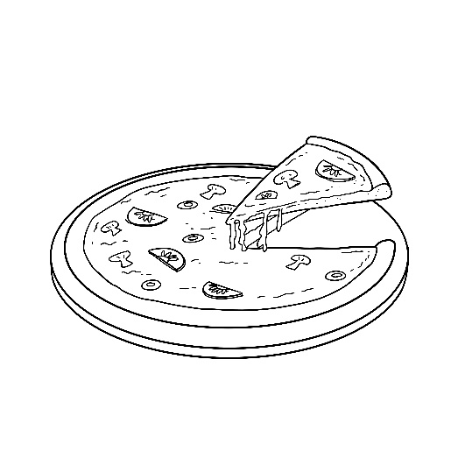
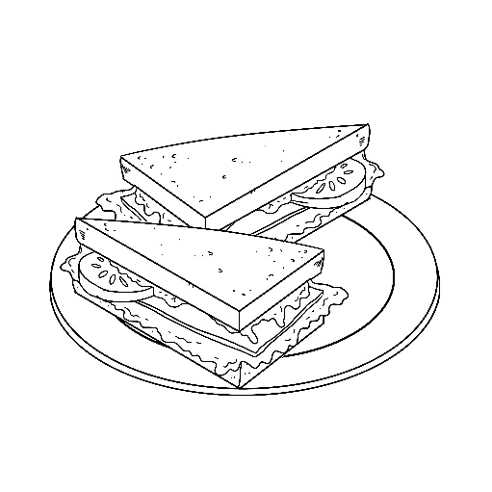

A B C

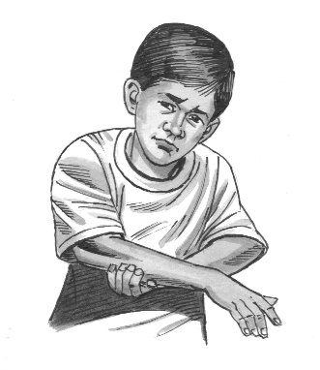
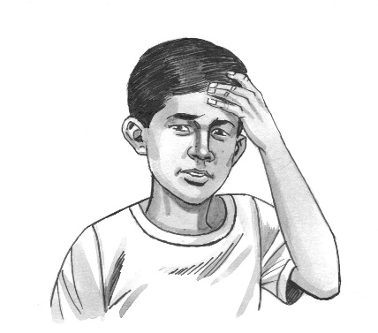
- Which part of his body has the boy hurt?
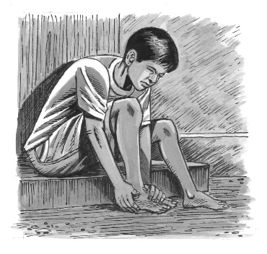

A B C

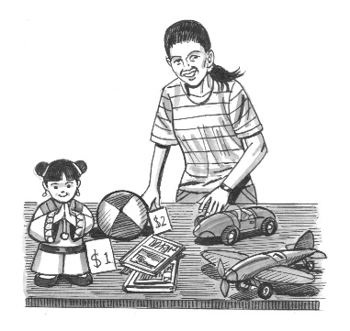
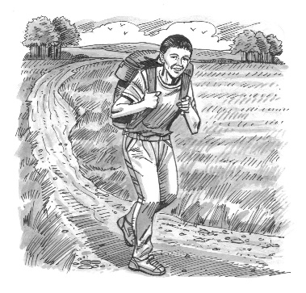
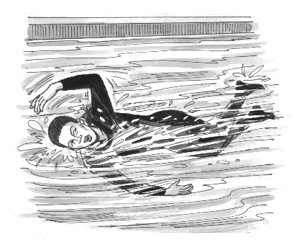
- What did the girl do to raise money for charity?

A B C

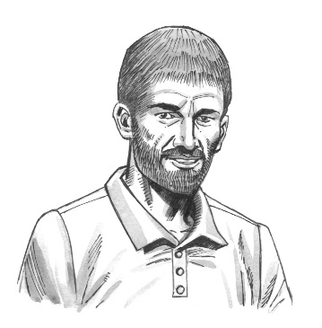
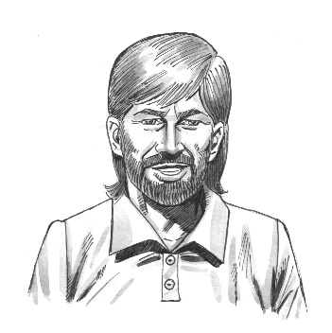
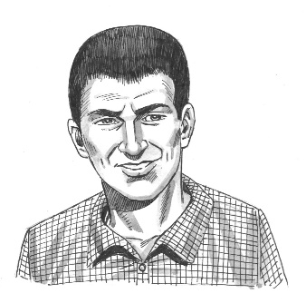
- Which person did the boy see in an advert?

Low res

A B C

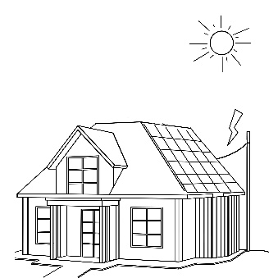
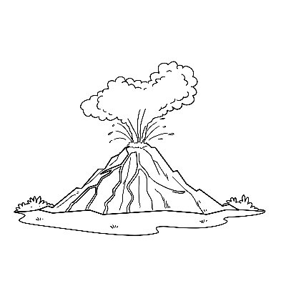
- What is the girl’s project about?
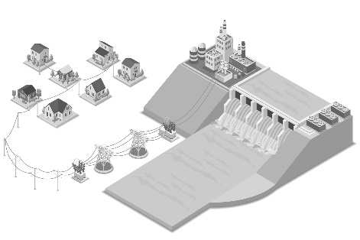
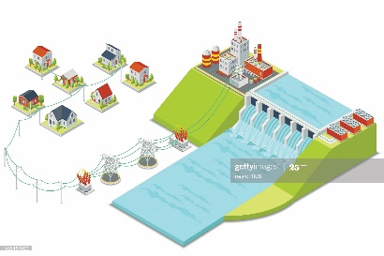

A B C

[Total: 5 marks]
Part 2
You will hear people talking in six different situations.
Circle the best answer, A, B or C.

- You hear two friends talking about an exhibition they went to.
What surprised them about it?
A how busy it was
B how interesting it was
C how small it was

- You hear two classmates talking about creating sculpture.
Why doesn’t the girl like creating sculpture?
A She never knows what to make.
B She always makes mistakes.
C She takes too long making it.

- You hear two friends talking about watching a film.
Which film do they decide to see?
A a science-fiction film
B a horror film
C a comedy film

- You hear a brother and sister talking about a music festival they’re going to.
What is the boy looking forward to most?
A the wide range of music
B seeing his favourite band
C meeting lots of friends

- You hear two friends talking about a book they both read.
They agree that:
A The characters were realistic.
B It had a disappointing ending.
C There was lots of action in it.
[Total: 5 marks]

Part 3
You will hear a student called Vishni giving a talk to a class about a Russian empress called
Catherine the Great.
Complete the sentences with a word, a number or a short phrase.

Catherine the Great

Catherine became Empress of Russia in (11) …………………………… .

Catherine was especially fond of (12) …………………………… art.

A building called The (13) ………………………… was built for Catherine’s art collection.

Catherine particularly enjoyed reading stories by (14) …………………………… writers.

Catherine ordered the setting up Russia’s first national (15) …………………………… system.

[Total: 5 marks]

Part 4
You will hear an interview with a young woman called Azra Erdal, who is a wildlife photographer.
Circle the best answer, A, B or C.

16 Azra became interested in photography when
A she received a camera as a gift.
B she started studying it at school.
C she went to an exhibition of photos.

17 How did Azra feel when her first photo was published?
A pleased by people’s comments
B surprised it was so popular
C disappointed by its size

18 Azra’s favourite photo shows
A a fish.
B a bird.
C a big cat.

19 Azra’s next photography trip is to
A an island.
B a very cold country.
C a jungle.

20 What advice does Azra give to young photographers?
A Buy good equipment.
B Learn from your mistakes.
C Study other people’s work.

[Total: 5 marks]

Part 5
You will hear five teenagers talking about music.
Choose from the list (A–H) what each speaker says about music. Write the correct letter in the
box next to each speaker.
There are three extra letters that you do not need to use.

A I’d like to be a professional musician.
B I listen to music in the evening. 21 Speaker 1
C It makes me feel better when I’m upset. 22 Speaker 2
D I listen to a range of genres. 23 Speaker 3
E I like similar music to my parents. 24 Speaker 4
F I’ve just started learning a musical instrument. 25 Speaker 5
G I wrote my first song recently.
H I download a lot of songs.

[Total: 5 marks]

Reading and Use of English
Part 1
For each question, circle the correct letter, A, B, C, or D.
Example:
0 A nicest B temperature C energy

Hydropower
………..
Hydropower is the name given to using the (0) of falling or flowing water for a range of purposes.
It has been used for many (1) of years. In the past, the power of flowing water was used
to (2) large wooden wheels called waterwheels. These were connected to large machines that produced the (3) needed for making bread.
…………
…………
…………
…………
More (4) , however, hydropower has been used for other things. Perhaps the most important of these is the use of hydropower to (5) electricity. There are (6) amounts of fossil fuels like coal and gas left on Earth. Hydropower, however, is a (7) resource, meaning that it will never run out. The only disadvantage of producing electricity in this way is that hydropower (8) can only be built in certain places, and there aren’t many of these sites available in most countries.
…………
…………
…………
…………

1 A hundreds B centuries C numbers D quantities
2 A corner B circle C turn D transfer
3 A grass B cereal C sauce D flour
4 A lately B recently C nowadays D newly
5 A cause B build C introduce D generate
6 A limited B controlled C contained D narrow
7 A returnable B refillable C renewable D reasonable
8 A positions B stations C locations D situations
[Total: 8 marks]

Part 2
Look at the text in each question. What does it say? Circle the correct letter, A, B or C.
Example:

Lily,
I haven’t forgotten that you’ve got an appointment after school today. If you go straight to the dentists, I’ll see you there and give you a lift home.
Dad
0
A Lily’s dad wants Lily to make an appointment at the dentists later today.

B Lily’s dad will pick Lily up from school and take her to the dentists.

C Lily’s dad will meet Lily at the dentists and take her back to their house.

From: Mr Daniels
Subject: Japanese classes

Unfortunately, the date on which these classes were due to start has had to change. They will now begin on 5th June rather than 30th May.
9
A Japanese classes run between 30th May and 5th June.

B The first Japanese class will be held on 5th June.

C The Japanese classes will begin earlier than expected.

10
Clothes in this section are on offer this week at half the usual price.
A There’s a 50% reduction in cost of items in this part of the store.

B Some of the clothes in this part of the shop are damaged.

C You can buy two items for the price of one in this section.


11
Nandita

The place where I’m staying on holiday is in the middle of nowhere! I was in two minds about whether to come here, but it’s wonderfully peaceful.
Aruna
A Aruna is glad she went on holiday with another person as there’s little to do.

B Aruna says she almost came home because her holiday destination was difficult to find.

C Aruna is pleased about her choice of holiday location despite having doubts about it.


12
Demir
I had toast for breakfast and there’s only one slice of bread left – not enough for your sandwiches. Sorry! I’ll get more on my way home from college.
Zeki
A Zeki has made Demir some sandwiches but didn’t have enough bread for his toast.

B Zeki has used almost all of their bread but will buy some more later.

C Zeki has forgotten to buy more bread so there’s only enough left for toast.

13
Drama Club

Today’s session will take place in the hall rather than in the dance studio, which is being decorated. It will be at the usual time of 4 p.m.


A Today’s Drama Club session has been cancelled as there are no rooms available.
NOTICEBOARD

B The time that the Drama Club starts has been changed for today’s session.

C Someone is painting the Drama Club’s usual room so today’s session is somewhere else.

[Total: 5 marks]

Part 3
Complete the conversation between two friends.
What does Helena say to Cho?
Write the correct letter, A–H, from the answers on the next page.
Example:
Helena: Hi Cho. Do you want to go to the cinema on Saturday?
………
Cho: 0 H

Helena: There’s a great new action movie on.
Cho: 14 …………

Helena: Well how about a crime thriller then?
Cho: 15 …………

Helena: There is. It’s got our favourite actor in it too.
Cho: 16 …………

Helena: Actually, can I meet you at the cinema? It starts at 11 a.m.
Cho: 17 …………

Helena: Great. That’ll give us time to get the tickets.
Cho: 18 …………

Helena: Good idea! There’s a nice café just opposite the cinema.
[Total: 5 marks]

A Oh yes, is there a good one on?
B OK. I’ll get there a few minutes before that then.
C I think comedy films are more fun.
D I don’t really like that kind of film.
E Yes. Shall we get something to eat afterwards?
F I can’t come at that time.
G Sounds good. Shall I come to your house first?
H I’d love to! What do you want to see?

Part 4
For each question, write the correct answer.
Write one word for each gap.

From: Karolina
To: Ana
Hi Ana,
…...……..
You know we wanted (0) to do some singing lessons together? Well, I (19)………… just
found some information about a private music school that looks really good. The reviews of it online
are much better (20)………… anywhere else. Oh, and I (21)………… talking to a friend of my
mum’s about it. She said that both of her children have (22)………… going to classes there for several years and love it. What (23)………… you think about applying there? I think we should do it
tomorrow (24)………… that we can start classes next week.
I really wish I (25)………… started singing classes years ago, but I’ve never had enough courage. Anyway, write back and tell me (26)………… you think!
Karolina
[Total: 8 marks]

Part 5
You are going to read four reviews of nature documentaries.
Choose from the sections A–D to answer the questions on the next page. The sections may be
chosen more than once.

A Ko Win reviews Living Island
Living Island follows the lives of four very different families of animals in a small area in the far northwest of the Caribbean island of Cuba. One of the species it focuses on, the bee hummingbird, is the smallest bird in the world. I fell in love with this tiny creature because its shiny feathers are such beautiful colours. It made me very angry, though, to learn that there aren’t many of them left because people have cut down much of their forest home. The series runs for another seven weeks – I can’t wait for the next episode!
B Emily reviews Natural Wonders
Natural Wonders is made by the same company that created Earth’s Amazing Islands, but is much better, in my opinion. Filmed and created over a period of two years, Natural Wonders shows a wide variety of animals that live in various locations and landscapes around the world. Many nature documentaries these days try to create stories for the animals in them, some of them funny and some sad, because they think this is what people want. Natural Wonders thankfully avoids this, and the use of music, showing exactly what the animals’ lives are actually like instead.
C Ignacio reviews Nature World
Perhaps the best thing about Nature World is how many different animals, some of which I’d never even heard of, they could fit into a documentary lasting one hour. The soundtrack, provided by one of the world’s greatest composers, is also excellent. There isn’t enough space to describe where each of the many animals live, but my favourite part showed a creature called a snow leopard hunting on the sides of a snow-filled valley. It was amazing how easily it ran up and down the steep hills. I wish I knew which country it was filmed in – I’d really like to go there!
D Asha reviews Life on the Edge
Unlike most documentaries, which try to tell viewers about the lives of rather too many animals,
Life on the Edge focuses on just one species of monkey. We get to know the personalities of each individual in the group. The scenes in which the young ones play tricks on each other made me laugh. I thought it was filmed in Indonesia, as I know this species of monkey lives there, but apparently the true location is kept a secret to protect the animals. I only wish the filmmakers had included more film of the monkeys as very tiny babies.
In which section does the writer:
27 describe how they felt during it? …………..
28 give an opinion about the music in it? …………..
29 suggest an improvement to it? …………..
30 say how pleased they were by the range of animals in it? …………..
31 explain exactly where in the world it was filmed? …………..
32 say how long it took to make? …………..
33 describe the landscape an animal lives in? …………..
34 say that parts of it were funny? …………..
35 explain why they like a particular animal in it so much? …………..
36 compare it to another programme? …………..
[Total: 10 marks]

Part 6
You are going to read an article about a boy describing his neighbourhood.
Read the questions on the next page.
For each question, choose the correct answer, A, B, C or D.

My neighbourhood
By 15-year-old Danny Hallett
I love my area! There’s a shopping centre, which has one or two shops I go to, and there are quite
a few parks and gardens too. The way people get on with each other here and help each other out is
what makes it such a special place to live. There are lots of residents from other parts of the country
and from around the world too, which always gives an area a nice atmosphere.
My family’s apartment isn’t in a big block like many apartments: it is half of an old house that’s been split into two flats. The best thing about it is the fantastic view we have of the river. There’s a busy and congested main road nearby, but it’s far enough away that we can hardly hear the noise of the traffic.
The street our apartment is on is short and there’s no way through to other parts of the city, so very
few cars use it.
I’ve just become involved in a charity group that raises money for improvements to the local park.
Last year, they managed to raise enough for a fantastic cycle track! Most parks have an area with
metal or wooden things that kids can climb on. The ones in our park are really old, so we’re trying
to get enough money to replace them. The park looks particularly good in spring and summer
when the trees and flowers are out. There’s almost no litter there thanks to all the rubbish bins.
What would make it an even better place to live, though, is if it were easier to get to, so that we had more visitors from other parts of the city. There’s no train station here and not many buses pass through.
I’m not sure why, as I’m sure people would come from all over to visit our new cinema. There are
loads of popular places to eat here, too, and the sports centre is one of the best in the city. I wouldn’t
want to live anywhere else!

37 What does Danny like most about his neighbourhood?
A the wide variety of people
B the shopping centre
C the community spirit
D the number of green spaces

38 Danny says that his family’s apartment
A is quite noisy.
B is in a car-free area.
C is in a large block.
D is overlooking water.

39 Danny is currently involved in raising money for
A new play equipment.
B new trees and plants.
C a new cycle track.
D new litter bins.

40 One improvement Danny would like to see in his area is
A a new sports centre.
B better transport links.
C more cafés and restaurants.
D a new cinema.

41 What would Danny write in his diary?
A I can’t believe how many people come to my area to use all of the facilities here.
B I really wish we didn’t live so close to a busy road – our apartment’s great apart from that.
C There are so many shops I like in the local area, it’s hard to choose one to go in first.
D The local park looks better at certain times of year, but I’m glad it’s so clean all the time.

42 What is Danny doing in this text?
A Explaining the good and bad points of living in a certain part of a city.
B Suggesting what other people could do to improve their own communities.
C Encouraging other people to move to the area where he lives.
D Describing his experiences of moving to an interesting new area.
[Total: 6 marks]

